

**DEPARTMENT:** ELECTRICAL AND ELECTRONICS ENGINEERING

**PROGRAM**: ELECTRONICS AND TELECOMMUNICATION TECHNOLOGY

**CLASS:** BTECH

Assignment 1

Lecturer Jean Claude Rukundo

**Module:** Electronic Device Design and Manufacturing

**Module Code:** ETTDM801

Done by:

IRAGUHA Euro Eloi 24RP10777

On, December 11, 2024

Assignment /50 marks

Part 1. Theory /30 marks

(each question carries 5 marks)

1. **Define the purpose of technical drawings in product design.**

**=>**

-**Clarity and Precision**: Technical drawings provide a clear, standardized representation of the product’s dimensions, materials, and assembly, ensuring that all stakeholders understand the design in the same way.

-**Documentation**: They act as a formal record of the design, preserving the specifications and details of the product for future reference, revisions, or troubleshooting.

-**Manufacturing Guidance**: Technical drawings convey essential information for manufacturing, such as tolerances, material types, assembly methods, and finishing details. This helps ensure the product is produced accurately and efficiently.

-**Quality Control**: By outlining precise measurements, material specifications, and assembly instructions, technical drawings help ensure that the final product adheres to design standards and functions as intended.

-**Compliance**: Technical drawings may include symbols and standards required for regulatory compliance, safety, and environmental considerations, ensuring that the product meets industry norms and legal requirements.

-**Collaboration and Iteration**: These drawings allow for easier collaboration across different teams (design, engineering, production) and serve as the basis for design iterations or modifications.

1. **List and describe the most commonly used projection angles in technical drawings.**



**-First-Angle Projection**: Used primarily in Europe and Asia. The views are projected from the front, top, and side, with the top view placed below the front view and the side view to the left.

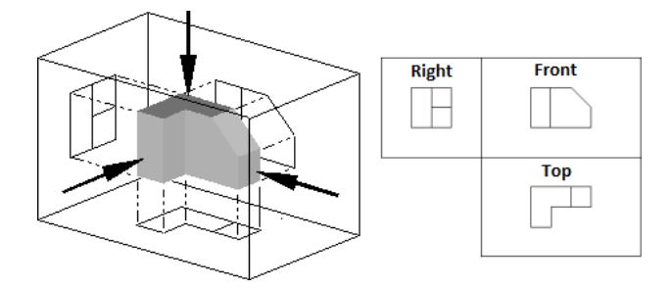

-**Third-Angle Projection**: Common in the United States and Canada. The front view is central, the top view is above, and the side view is to the right, giving a more intuitive layout of views.

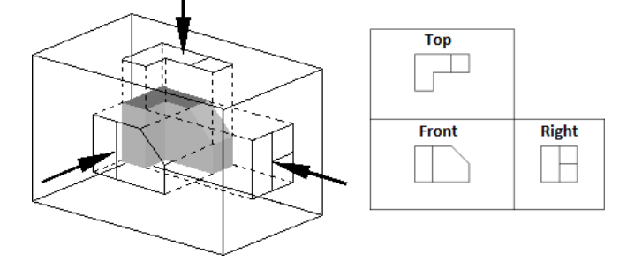

-**Isometric Projection**: A 3D projection where the object is rotated so that all three axes (height, width, depth) are shown at equal angles (120°), making all dimensions appear at the same scale.

-**Dimetric Projection**: A type of axonometric projection where two axes have the same scale, and the third is different, providing a view that distorts depth more than isometric.

-**Trimetric Projection**: A more complex axonometric projection where all three axes are scaled differently, resulting in a highly distorted view but useful for emphasizing certain features.

-**Oblique Projection**: The front face is shown directly, while depth is projected at an angle (usually 45°), giving a quick but distorted representation of depth.

1. **Explain the function of the following features in SolidWorks:**
2. **Extrude Boss/Base:** Creates 3D geometry by extruding a 2D sketch, adding material to form solid shapes.
3. **Fillet:** Rounds off sharp edges or corners, creating smooth transitions between faces.
4. **Extrude Cut:** Removes material from a 3D model by extruding a 2D sketch, creating holes or cutouts.
5. **Offset:** Creates a parallel copy of a sketch or curve at a specified distance.
6. **Convert entities**: converts selected edges and sketch entities into identical entities by projecting them onto sketch plane or face.
7. **Chamfer:** Bevels sharp edges at a specified angle, creating flat surfaces instead of sharp corners.
8. **Mirror:** Creates a symmetric copy of features, bodies, or sketches across a specified plane or line.
9. **Sketch Pattern:** Repeats a sketch or part of a sketch in a specified pattern (linear, circular, etc.), saving time on repetitive designs.
10. **Which is the common 3D file format used for 3D printing?**

* File Extension: .stl(Standard Tessellation Language)

1. **Mention a common slicer software used before printing and how does it prepare a model for 3D printing?**

* A common slicer software used before 3D printing is Ultimaker Cura.

**It prepares a model for printing by:**

-**Importing the Model:** The 3D model is loaded into the software.

-**Positioning:** The model is positioned, scaled, or rotated on the print bed.

-**Slicing:** The model is divided into thin horizontal layers.

-**Toolpath Generation:** The software creates the movement paths for the printer to follow.

-**Adding Supports:** Supports are added for overhangs and complex features.

-**G-code Generation:** The software generates G-code, which contains the printer's instructions.

-**Exporting G-code:** The G-code is saved and transferred to the printer for execution.

1. List and explain basic components of 3D printing.

* the basic components of 3D printing include:

-**3D Printer (Hardware):** The machine that builds the object layer by layer based on instructions.

-**Print Bed:** The surface where the model is built, sometimes heated to prevent warping.

-**Extruder/Print Head:** Heats and extrudes material onto the print bed to form each layer.

-**Filament (Material):** The material (usually plastic) used for 3D printing, which is melted and deposited layer by layer.

-**Slicer Software:** Prepares the 3D model by slicing it into layers and generating G-code for the printer.

-**G-code:** Instructions that tell the printer how to move and extrude material.

-**Cooling Fans**: Help cool the material as it is printed to prevent warping and ensure quality.

-**Power Supply:** Provides electrical power to the printer’s components.

-**Control Board/Software:** Interprets G-code and controls the printer’s movements.

-**Endstops/Sensors:** Ensure proper positioning and prevent the printer from moving beyond its limits.

**Part 2: Practice/20 marks**

(Each question carries 10 marks

1. Design a functional **PCB enclosure** for a rectangular PCB with the following specifications:

* Dimensions: 100 mm x 60 mm x 20 mm for each cover( bottom and top)
* Features to include:
  + - Ventilation slots on the top cover.
    - Space for screen on top cover
    - Access port for a USB connector
* Create a detailed technical drawing for the enclosure, including Top, front, and side views and dimensions
* Submit SolidWorks part file (.SLDPRT) and Technical drawing in PDF

1. Provide a short report (max 2 pages) explaining your design choices and any challenges encountered.

**GOOD LUCK!!!**